Restorative Justice Ministries Board “Discovery” Workshop
Thursday, November 10, 2016

Executive Overview

As a result of the “Discovery Workshop” held on November 10, 2016, “Mentoring”, “Training of Volunteers”, and “Discipleship” are the primary ways that RJMs’ Board and Volunteer participants believe they can impact indviduals (inmates, families, staff) over the next 2 to 3 years. These three groups made up over two thirds (71%) of total response.

More specificially, the group “Mentoring” made up 27% of the whole with a 59% focus on re-entry and its’ process. The group entitled “Training of Volunteers” made up 25% of the whole and within this category 81% viewed training needed to be specific to trauma care, life skills classes and Bible studies. Finally, the “Discipleship” group composed 19% and showed heavy emphasis in two sub-categories, “Transformation over Behavior Modification”, and the teaching of “How to study God’s Word.”

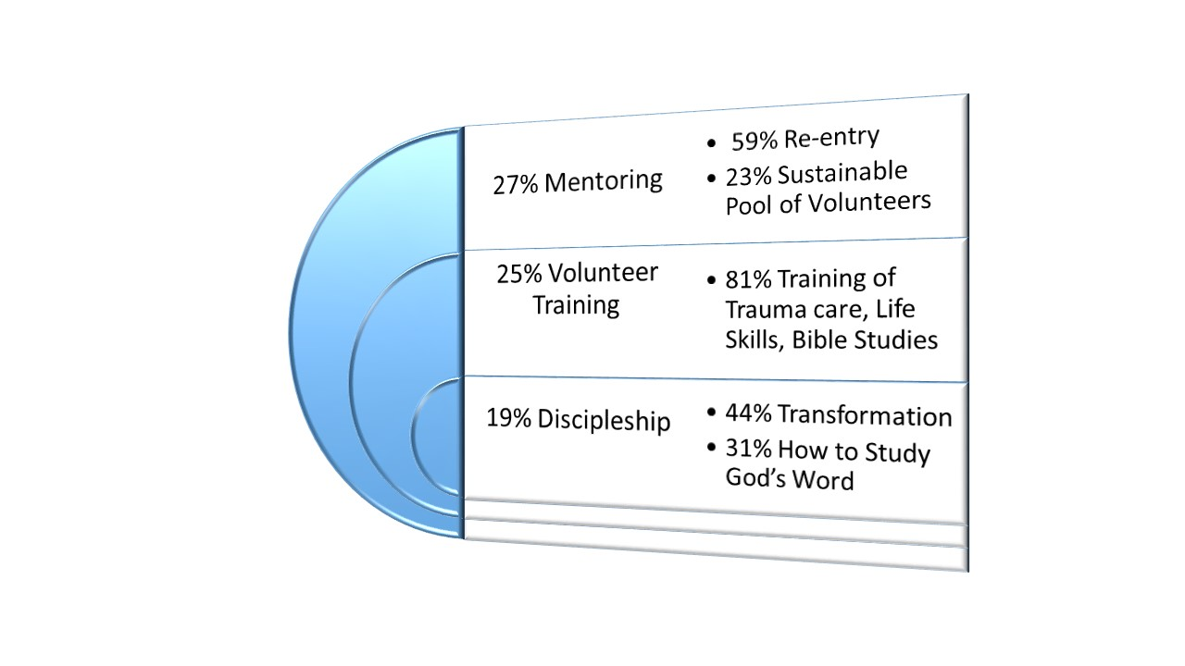

Program Introduction
A Restorative Justice Ministry (RJM) “Discovery Workshop” was conducted Thursday, November 10, 2016, at the Brazos County Detention Center. Nineteen (19) RJM administrators, board members and volunteers participated in an interactive and facilitated nominal group technique discussion to address how RJM can best serve the individuals they serve (inmates, families, staff).

Each participant was able to share their RJM interest and role in the ministry. After participants shared their respective roles and ideas about RJM, a facilitated discovery workshop was conducted to identify the most effective ways RJM can impact individuals it serves (inmates, families, staff) in the next 2-3 years.

:: Discovery Workshop ::
Discovery Question: What are the two most effective ways the Restorative Justice Ministry (RJM) can impact individuals (inmates, families, staff) it serves in the next 2-3 years.

Participants were requested to give two responses to the above question. Without discussion, each participant wrote each their two (2) responses on a separate sheet of paper. Each response was displayed on a “sticky board” for all to view. Each participant read his or her response placed it on the board. The facilitated process also included grouping responses into similar categories. Participants were responsible for the grouping.

Nine (9) categories were identified and named by participants (Table 1). In the final step, each participant had 5 votes to cast for their most effective ways RJM can impact inmates, families and staff in the next 2-3 years.

TABLE 1. WAYS RESTORATIVE JUSTICE MINISTRY (RJM) CAN MOST EFFECTIVELY IMPACT “INMATES, FAMILIES AND STAFF” IN THE NEXT 2-3 YEARS :: RANKED BY DISCOVERY WORKSHOP PARTICIPANT VOTES
RANK | WAYS TO IMPACT MOST EFFECTIVELY | VOTES | % OF TOTAL
1 | MENTORING | 22 | 27 %
2 | VOLUNTEER TRAINING | 21 | 25 %
4 | FAMILY MINISTRY | 8 | 19%
4 | LIFE SKILLS | 8 | 10 %
5 | STAFF OUTREACH | 4 | 10 %
6 | INTERNAL COMMUNICATIONS | 2 | 2 %
6 | INMATE SUPPORT | 2 | 2 %
6 | LOGISTICS | 2 | 2 %

TABLE 2. PARTICIPANT SUGGESTIONS FOR WAYS RESTORATIVE JUSTICE MINISTRY (RJM) CAN EFFECTIVELY IMPACT “INMATES, FAMILIES AND STAFF” IN THE NEXT 2-3 YEARS
MENTORING (22)
28. Support Re-Entry Efforts & Program (6)
-After care
-Transition
-Continued relationships
30. Connections Mentoring Inside to Outside (6)
29. Develop mentoring program Find sustainable volunteer pools. (5)
6. Mentorship (3)
23. Nonjudgmental Support Mentorship (1)
24. Effective Re-entry Program (1)
5. Develop a mentoring program utilizing local churches to provide mature Christians as mentors to inmates inside and ex-inmates outside

VOLUNTEER TRAINING (21)
33. Create a Train the Trainer Class for Life Skills, Bible Studies that include basic teaching approaches and prison “mind set” and “trauma” counseling /Biblical (9)
14. Training for RJM Volunteers (5)
-Life Skills
-Bible Study
-Trauma – Informed Care
19. Volunteers (3)
-Training
-What materials to teach
-More communication between our purpose, RJM and them.
15. Parenthood Teaching (Spiritual) (2)
9. Keep the classes simple :: Easy to understand :: Easy to Remember :: Not Necessary to use all material in 1 hour. (1)
7. Recruit additional workers. (1)

3 DISCIPLESHIP (16)
27. Discipleship :: Transformation over behavior modification (7)
8. Show (teach) How to Study God’s Word! (Spiritual Mentoring) (5)
36. Get the Word to Them (A Copy of Their Own) (2)
17. Post-visit Discipleship (After Response to the Gospel) (1)
26. Provide Spiritual after care process for inmates that remain in system. (1)

3 FAMILY MINISTRY (9)
Family ministry (general) (5)
34. Contact inmates Children – Family (1)
35. Teaching about Relationship Building (3)
32. Families need to know “what to expect when visiting the institution. How they can help (inside) -- resources
5 LIFE SKILLS (8)
Life Skills General (1)
1. Expand life skills to include hands on technical training (1)
2. Balance Life Style (1)
3. Professional Development :: Inmates (2)
10. Continue with Spiritual Recovery & Provide Mentorship
-Long term inmates (1)
16. Rejuvenate Life Skills classes update, change, and modernize
18. Life Skills Classes with Biblical Principles inside & same classes outside (1)
21. Personal Responsibility (1)

5 STAFF OUTREACH (4)
31b. Offer a Bible study time for the staff (One for ladies and/or one for men) (4)
6 INTERNAL COMMUNICATIONS (2)
12. Staff Reports (2)
4. Effective communication program for volunteers.
6 INMATE SUPPORT (2)
11. Show more Love & Care. (1)
27. Continue current programs (1)
20. Provide resources for court appearance attire.
6 LOGISTICS (2)
13. Schedule more Bible studies. (1)
25. Class size of 15 seems to work well. (1)

